MACHINE LEARNING
Unit-I
-----------------------------------------------------------------------------------------------------------------------
UNIT-I: Introduction to Machine Learning: Evolution of Machine Learning, Paradigms for ML, Learning by Rote, Learning by Induction, Reinforcement Learning, Types of Data, Matching, Stages in Machine Learning, Data Acquisition, Feature Engineering, Data Representation, Model Selection, Model Learning, Model Evaluation, Model Prediction, Search and Learning, Data Sets.
------------------------------------------------------------------------------------------------------------------------
Introduction to Machine Learning:
In the real world, we are surrounded by humans who can learn everything from their experiences with their learning capability, and we have computers or machines which work on our instructions. But can a machine also learn from experiences or past data like a human does? So here comes the role of Machine Learning.
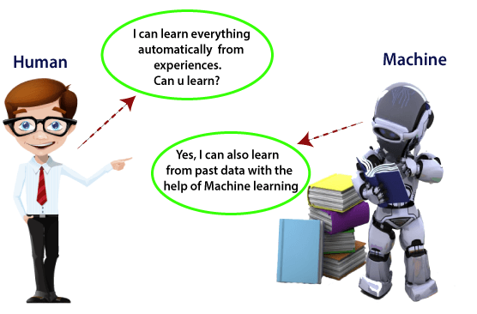

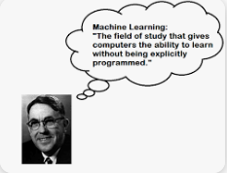
Arthur Samuel first used the term "machine learning"
in 1959.

Machine learning is a subset of AI that allows machines to learn and improve from data with out being explicityly programmed (Explicitly programming means telling the computers what to do by providing exact rules.).It uses algorithms to analyze large amounts of data, identify patterns, and make decisions. Machine learning models are the output of applying an algorithm to a data set.
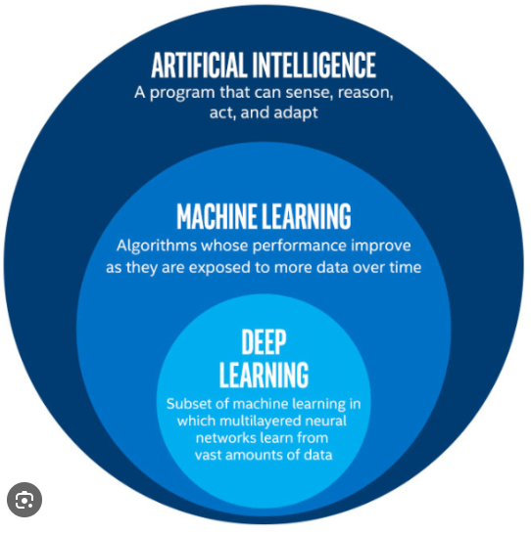

How it works- Uses algorithms to analyze data, identify patterns, and make decisions
How it improves-Improves performance over time as it's trained on more data
Applications-Healthcare, manufacturing, retail, energy, and financial services
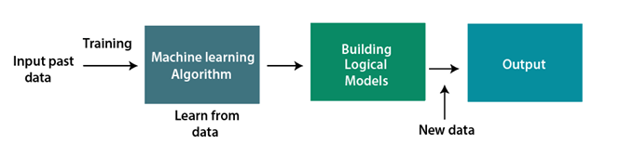
--------------------------------

Evolution of Machine Learning:

1. Alan Turing (1912–1954)
- Often considered the father of artificial intelligence, Turing's 1950 paper Computing Machinery and Intelligence proposed the concept of machine intelligence and introduced the "Turing Test."
- Though not directly tied to modern ML, his work laid the philosophical groundwork for machines that could "learn."

2. Arthur Samuel (1901–1990)
- Who: American computer scientist at IBM.
- Contribution: Coined the term "machine learning" in 1959.
- Legacy: Developed a program in the 1950s that learned to play checkers, one of the first examples of a machine improving its performance over time through self-play.

3. Frank Rosenblatt (1928–1971)
- Who: American psychologist and computer scientist.
- Contribution: Introduced the Perceptron in 1958, a type of artificial neural network.
- Legacy: The Perceptron was a precursor to modern neural networks, though it faced criticism for its limitations, highlighted in Minsky and Papert's 1969 book.

4. Geoffrey Hinton, Yann LeCun, and Yoshua Bengio (Modern ML Pioneers)
- Known as the "godfathers of deep learning," they revitalized interest in neural networks in the 1980s and 1990s.
  - Hinton: Popularized backpropagation and developed modern deep learning frameworks.
  - LeCun: Invented convolutional neural networks (CNNs).
  - Bengio: Contributed to advancements in deep learning architectures.
------------------------------------
Paradigms for ML:
Machine Learning (ML) paradigms define how a model is trained and the approach it takes to learn from data. Below are the major paradigms in ML, each suited to different types of problems:
1. Supervised Learning
2. Unsupervised Learning
3. Semi supervised Learning
4.Reinforcement Learning
Supervised Learning:
Supervised learning is the most common learning paradigm. In supervised learning, the computer learns from a set of input-output pairs, which are called labeled examples:
The goal of supervised learning is usually to train a predictive model from these pairs. A predictive model is a program that is able to guess the output value (label) for a new unseen input. Simply supervised learning is to Learn from labeled data where each input has a corresponding output (target).
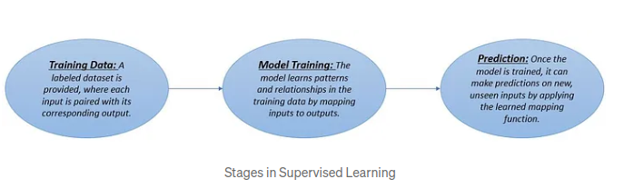
Ex:
Suppose we have an input dataset of cats and dog images. So, first, we will provide the training to the machine to understand the images, such as the shape & size of the tail of cat and dog, Shape of eyes, colour, height (dogs are taller, cats are smaller), etc. After completion of training, we input the picture of a cat and ask the machine to identify the object and predict the output. Now, the machine is well trained, so it will check all the features of the object, such as height, shape, colour, eyes, ears, tail, etc., and find that it's a cat. So, it will put it in the Cat category. This is the process of how the machine identifies the objects in Supervised Learning.
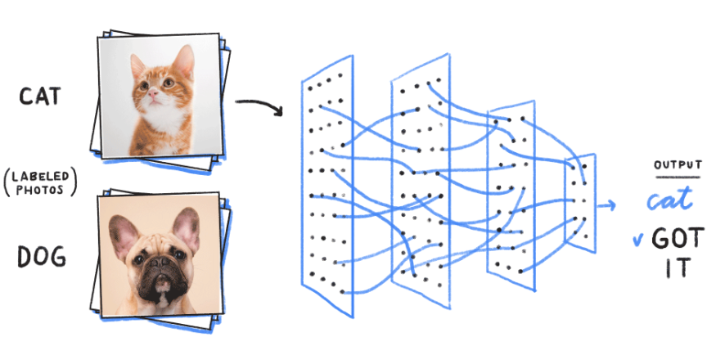
Ex:
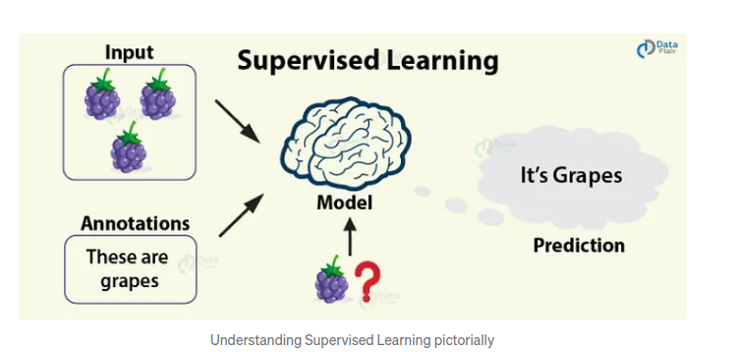
Detailed Insight into the learning paradigm:
- In supervised learning, the computer learns from a labeled dataset, i.e., a set of input-output pairs.
- Supervised learning aims to train a predictive model by feeding these input-output pairs of data into statistical algorithms.
- The trained model learns the relationship between the input and output and becomes capable of predicting output values for new unseen or future input values.
- The input or the independent variable(s) is/are called Feature(s), and the output or the dependent variable(s) is/are calledTarget Variable(s) or Label(s).
Ex:
Let’s consider an example of the application of supervised learning. Following is a demo dataset of animal characteristics:
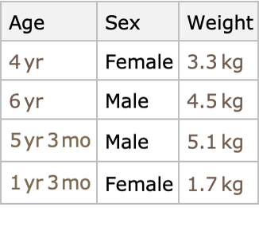
Let’s set the columns ‘Age’ and ‘Sex’ as Features and ‘Weight’ as the Target Variable. Therefore, after we feed this data into a statistical algorithm and build a predictive model, it will be able to predict ‘Weight’ for any values of ‘Age’ and ‘Sex’ that are not present in the dataset used to train the model.
Ex: Consider the dataset
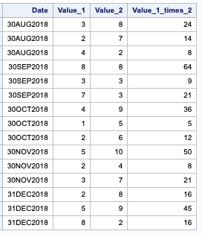
Suppose ‘Value_1’ and ‘Value_2’ are input variables and ‘Value_1_times_2’ is the output variable. Although we can infer manually from the data that the output result is the product of the input values, the data do not explicitly state that the mathematical formula of multiplication is being used in this situation.
If we feed this data into a machine learning algorithm to build a predictive model, it will automatically detect the relationship between the input and the output variables and will be able to predict the output values for new unseen (future data) input values.
Ex:

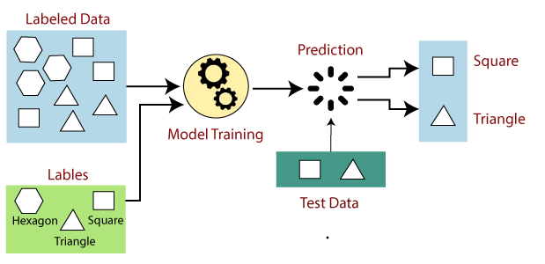
Suppose we have a dataset of different types of shapes which includes square, rectangle, triangle, and Polygon. Now the first step is that we need to train the model for each shape.
- If the given shape has four sides, and all the sides are equal, then it will be labelled as aSquare.
- If the given shape has three sides, then it will be labelled as a triangle.
- If the given shape has six equal sides then it will be labelled as hexagon.
Now, after training, we test our model using the test set, and the task of the model is to identify the shape.
The machine is already trained on all types of shapes, and when it finds a new shape, it classifies the shape on the bases of a number of sides, and predicts the output.
Ex:
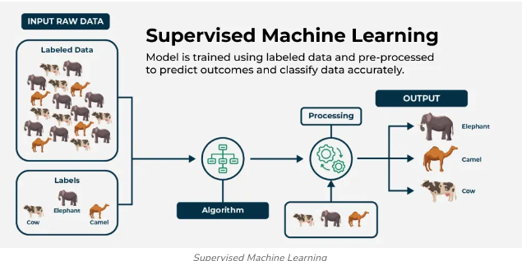
Insummary, supervised machine learning involves training a model on labeled data to learn patterns and relationships, which it then uses to make accurate predictions on new data.
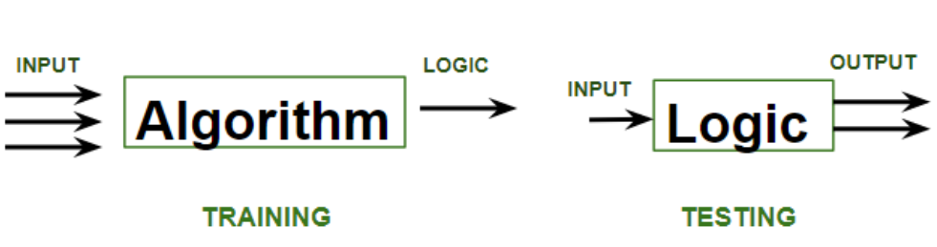

In the image above,
- Training phase involves feeding the algorithm labeled data, where each data point is paired with its correct output. The algorithm learns to identify patterns and relationships between the input and output data.
- Testing phase involves feeding the algorithm new, unseen data and evaluating its ability to predict the correct output based on the learned patterns.

Workflow of Supervised Learning
- Collect Data: Gather labeled data relevant to the problem.
- Preprocess Data: Clean, normalize, and transform the data into a suitable format for training.
- Split Data: Divide the dataset into training and testing subsets (e.g., 80% training, 20% testing).
- Train Model: Use the training data to teach the model the relationship between inputs and outputs.
- Evaluate Model: Test the model on the testing data to assess its performance using metrics like accuracy, precision, recall, or mean squared error.
- Deploy Model: Use the trained model for making predictions on new, unseen data.

Advantages of Supervised learning:
- With the help of supervised learning, the model can predict the output on the basis of prior experiences.
- In supervised learning, we can have an exact idea about the classes of objects.
- Supervised learning model helps us to solve various real-world problems such as fraud detection, spam filtering, etc.

Disadvantages:
- Supervised learning models are not suitable for handling the complex tasks.
- Supervised learning cannot predict the correct output if the test data is different from the training dataset.
- Training required lots of computation times.
- In supervised learning, we need enough knowledge about the classes of object.

Supervised Learning is classified into two types
1.Classification.
2.Regression.
1.Classification:
Classification algorithms are used when the output variable is categorical, which means there are two classes such as Yes-No, Male-Female, True-false, etc.
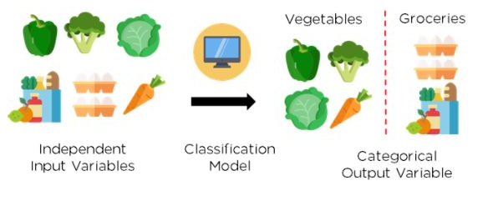

Ex:
- Spam Detection: Classify emails as "spam" or "not spam" using features like word frequency and sender information.
- Image Recognition: Identify objects in images (e.g., cats vs. dogs) using pixel data.
- Sentiment Analysis: Classify customer reviews as "positive," "negative," or "neutral" based on text data.
In classification algorithm, a discrete output function(y) is mapped to input variable(x).
y=f(x),where y=categorical output
Classification algorithms can be better understood using the below diagram. In the below diagram, there are two classes, class A and Class B. These classes have features that are similar to each other and dissimilar to other classes.
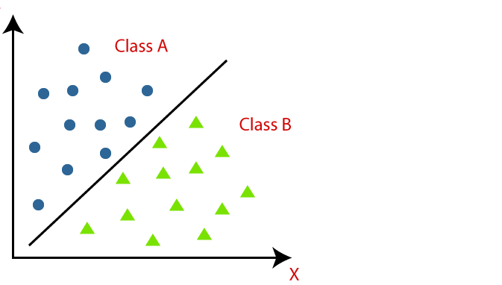

The algorithm which implements the classification on a dataset is known as a classifier. There are two types of Classifications:
- Binary Classifier:If the classification problem has only two possible outcomes, then it is
called as Binary Classifier.
Examples:YES or NO, MALE or FEMALE, SPAM or NOT SPAM, CAT or DOG, etc.
- Multi-class Classifier:If a classification problem has more than two outcomes, then it is called as Multi-class Classifier.
Example:Classifications of types of crops, Classification of types of music.
Learners in Classification Problems:
In the classification problems, there are two types of learners:
- Lazy Learners:
Lazy Learner firstly stores the training dataset and wait until it receives the test dataset. In Lazy learner case, classification is done on the basis of the most related data stored in the training dataset. It takes less time in training but more time for predictions.
Example:K-NN algorithm
- Eager Learners:
Eager Learners develop a classification model based on a training dataset before receiving a test dataset. Opposite to Lazy learners, Eager Learner takes more time in learning, and less time in prediction.
Example:Decision Trees, Naive Bayes, ANN.

Types of ML Classification Algorithms:
Linear Models
  - Logistic Regression
  - Support Vector Machines
Non-Linear Models
  - K-Nearest Neighbours
  - Kernel SVM
  - Naive Bayes
  - Decision Tree Classification
  - Random Forest Classification
2. Regression:
It is a supervised machine learning technique, used to predict the value of the dependent variable for new, unseen data. It models the relationship between the input features and the target variable, allowing for the estimation or prediction of numerical values.

Terminologies Related to the Regression Analysis in Machine Learning
- Response Variable: The primary factor to predict or understand in regression, also known as the dependent variable or target variable.
Ex:
- House Price Prediction:
  - Response Variable: House price (in dollars)
  - Explanatory Variables: Square footage, number of bedrooms, location, etc.
- Exam Performance:
  - Response Variable: Student's score (percentage or points)
  - Explanatory Variables: Hours studied, attendance rate, difficulty of the exam, etc.

- Predictor Variable: Factors influencing the response variable, used to predict its values; also called independent variables.
Ex:

Examples of Predictor Variables:
- House Price Prediction:
  - Predictor Variables:
    - Square footage of the house
    - Number of bedrooms
    - Location (e.g., urban or rural)
    - Age of the house
- Exam Performance:
  - Predictor Variables:
    - Hours spent studying
    - Number of practice tests completed
    - Attendance rate
- Outliers: In regression analysis, outliers are data points where the response variable or predictor variable values significantly deviate from the overall pattern of the data. Outliers can affect the accuracy of regression models and may need to be handled carefully.

Ex:

1. House Price Prediction:
- Response Variable Outlier: A luxury mansion priced at $10 million in a dataset of typical homes ranging from $200,000 to $500,000.
- Predictor Variable Outlier: A house with 15 bedrooms in a dataset where most homes have 2–5 bedrooms.

2. Exam Performance:
- Response Variable Outlier: A student scoring 0% in an exam where most students scored between 70% and 90%.
- Predictor Variable Outlier: A student who studied 100+ hours while others studied 10–30 hours.
- Multicollinearity occurs when two or more independent variables in a regression model are highly correlated, meaning they provide redundant or overlapping information about the response variable. This can make it difficult to determine the individual effect of each predictor on the response.

Ex:

1. House Price Prediction:
- Highly Correlated Variables:
  - Square footage of the house and the number of rooms.
  - Lot size and house size.
  - Age of the house and whether renovations were performed.

2. Exam Performance:
- Highly Correlated Variables:
  - Hours spent studying and the number of practice tests completed.
  - Attendance rate and class participation score.
- Overfitting: Overfitting occurs when an algorithm performs well on training but poorly on testing, while underfitting indicates poor performance on dataset.
- Underfitting: It represents the inability of the model to learn the training data effectively result in poor performance both on the training and testing data. In simple terms, an underfit model’s are inaccurate, especially when applied to new, unseen examples.
Ex:

Examples of Overfitting and Underfitting

1. House Price Prediction
- Overfitting:
  - A model includes complex features like specific house colors or unique architecture designs that don't generalize well to other houses.
  - Example: The model perfectly predicts house prices in the training dataset but fails on new data because it has "memorized" irrelevant patterns.
- Underfitting:
  - A model only uses the average number of rooms and ignores key predictors like location or square footage.
  - Example: It predicts every house price as the same regardless of significant differences in features.

2. Exam Performance
- Overfitting:
  - A model learns specific quirks of the training data, such as outliers in scores or specific exam difficulty levels.
  - Example: Predicts a student’s score as 100% because it encountered a perfect score in training data with similar features.
- Underfitting:
  - A model considers only the number of hours studied, ignoring attendance and study materials.
  - Example: Predicts scores inaccurately because it overlooks other factors.

Regression Types
There are two main types of regression:
- Simple Regression
  - Used to predict a continuous dependent variable based on a single independent variable.
  - Simple linear regression should be used when there is only a single independent variable.
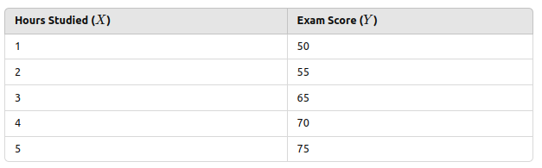
- Multiple Regression
  - Used to predict a continuous dependent variable based on multiple independent variables.
  - Multiple linear regression should be used when there are multiple independent variables.
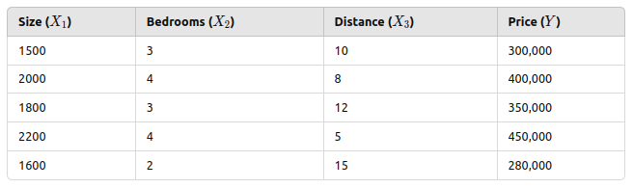
- NonLinear Regression
  - Relationship between the dependent variable and independent variable(s) follows a nonlinear pattern.
  - Provides flexibility in modeling a wide range of functional forms.

Regression Algorithms
There are many different types of regression algorithms,
- Linear Regression
It is one of the simplest and most widely used statistical models. This assumes that there is a linear relationship between the independent and dependent variables. This means that the change in the dependent variable is proportional to the change in the independent variables.
- Polynomial Regression
  - Polynomial regression is used to model nonlinear relationships between the dependent variable and the independent variables. It adds polynomial terms to the linear regression model to capture more complex relationships.
- Support Vector Regression (SVR)
  - Support vector regression (SVR) is a type of regression algorithm that is based on the support vector machine (SVM) algorithm. SVM is a type of algorithm that is used for classification tasks, but it can also be used for regression tasks. SVR works by finding a hyperplane that minimizes the sum of the squared residuals between the predicted and actual values.
- Decision Tree Regression
  - Decision tree regression is a type of regression algorithm that builds a decision tree to predict the target value. A decision tree is a tree-like structure that consists of nodes and branches. Each node represents a decision, and each branch represents the outcome of that decision. The goal of decision tree regression is to build a tree that can accurately predict the target value for new data points.
- Random Forest Regression
  - Random forest regression is an ensemble method that combines multiple decision trees to predict the target value. Ensemble methods are a type of machine learning algorithm that combines multiple models to improve the performance of the overall model. Random forest regression works by building a large number of decision trees, each of which is trained on a different subset of the training data. The final prediction is made by averaging the predictions of all of the trees.
------------------------------------

Learning by Rote:
In the context of machine learning (ML), the concept of "learning by rote" can be compared to memorization without generalization. This phenomenon occurs when a model learns the exact details of the training data without understanding the underlying patterns, which is often referred to as overfitting.

Characteristics of Rote Learning in ML:
- Memorization of Training Data:
  - The model perfectly predicts outcomes for the training dataset.
  - Performance drastically drops when evaluated on unseen data.
- Lack of Generalization:
  - The model fails to apply learned patterns to new, unseen data because it hasn't understood the relationships or patterns in the data.
- Symptoms of Overfitting:
  - High training accuracy but low validation/test accuracy.
  - Inability to make meaningful predictions on data outside the training set.

Causes of Rote Learning in ML:
- Insufficient Training Data: The model may memorize limited data points rather than learning patterns.
- Model Complexity: Overly complex models (e.g., deep neural networks with many parameters) can memorize training data if not regularized.
- Lack of Regularization: Absence of techniques like dropout, L1/L2 regularization, or early stopping.
- Noisy Data: Irrelevant features or noise can lead to memorization of spurious patterns.

Avoiding Rote Learning in ML:
- Regularization Techniques:
  - Dropout: Randomly disabling neurons during training to prevent reliance on specific pathways.
  - L1/L2 Regularization: Penalizing large weights to discourage overfitting.
- Data Augmentation:
  - Expanding the training dataset by creating variations of existing data points.
- Cross-Validation:
  - Ensuring that the model performs well on unseen subsets of data during training.
- Simpler Models:
  - Using less complex models for datasets that don’t require high-capacity models.
- Early Stopping:
  - Halting training when performance on the validation set stops improving.
- Increasing Data:
  - Collecting more diverse training examples to help the model learn generalizable patterns.
In human terms, rote learning in ML would be akin to a student memorizing answers for a test without understanding the subject. While the student may score well on predictable questions, they would struggle with novel or application-based problems—similar to how an overfitted model fails on unseen data.
Ex:
A dataset of images of digits from 0 to 9.

Scenario:
- Dataset:
  - Training set: 60,000 images of handwritten digits.
  - Test set: 10,000 unseen images of handwritten digits.
- Model:
  - A deep neural network with a large number of layers and neurons, making it highly complex.
- Training:
  - The model is trained for too many epochs without any regularization techniques.
  - As a result, the model learns to memorize every pixel pattern of the training images instead of generalizing patterns like "shapes of digits."
- Outcome:
  - Training accuracy: 100% (the model memorized the training data perfectly).
  - Test accuracy: 50% (the model fails to generalize to unseen data).

Observations:
- High Variance: The gap between training and test accuracy is large, indicating overfitting.
- The model has effectively "learned by rote," memorizing training examples but failing to recognize new examples of digits.
Ex:
A student preparing for a science exam focuses solely on memorizing the exact definitions provided in the textbook. For example:
- Definition of Photosynthesis: "Photosynthesis is the process by which green plants use sunlight, carbon dioxide, and water to make food and release oxygen."

Exam Performance:
- Direct Question:
  - Question: "What is photosynthesis?"
  - Student's Response: The student recalls and writes the memorized definition word-for-word.
  - Outcome: The student scores full marks because the answer matches the expected response.
- Application-Based Question:
  - Question: "Why is photosynthesis important for the environment?"
  - Student's Response: The student struggles to answer because they never thought beyond the definition. They can’t explain the role of photosynthesis in producing oxygen or supporting the food chain.
  - Outcome: The student loses marks because they didn’t understand the concept, only the definition.

Observations:
- Strengths of Rote Learning:
  - The student performs well on straightforward recall-based questions.
- Weaknesses:
  - The student struggles with questions requiring explanation, reasoning, or application.

Improving Exam Performance:
To avoid relying solely on rote learning, the student could:
- Understand the Concept:
  - Learn how and why photosynthesis occurs, using diagrams or experiments.
- Connect to Real-Life Examples:
  - Study the importance of plants in reducing carbon dioxide levels and producing oxygen.
- Practice Application-Based Questions:
  - Solve questions like: "What would happen if there were no green plants on Earth?" or "How is photosynthesis related to global warming?"
- Use Active Recall and Spaced Repetition:
  - Regularly test understanding through practice quizzes and flashcards.
-------------------------------
Learning by Induction:
Learning by induction in machine learning refers to the process of deriving general rules or models from specific instances of data. This approach enables a machine learning algorithm to infer patterns, relationships, or concepts from observed examples and then apply these generalizations to new, unseen data.

Characteristics of Inductive Learning:
- Generalization:
  - The model learns a hypothesis or rule that can make predictions beyond the training data.
  - Example: A model infers that all cats have whiskers after observing many images of cats with whiskers.
- Data-Driven:
  - Relies on patterns and relationships found in the training data.
- Key Assumption:
  - The future data distribution will be similar to the training data distribution (also known as the i.i.d. assumption: independent and identically distributed).

Examples of Inductive Learning in ML:
- Decision Trees:
  - A decision tree learns rules like:
    - If an animal has feathers and flies, it’s a bird.
  - These rules are derived from training data and then used to classify new instances.
- Linear Regression:
  - The model learns a general relationship y=mx+b from training data points to predict y for new x values.
- Neural Networks:
  - A neural network generalizes patterns from labeled data, like identifying features of a face to recognize unseen faces.
- Support Vector Machines (SVM):
  - SVMs create a hyperplane that separates data points of different classes based on observed training examples.

Inductive vs. Rote Learning:
Aspect | Inductive Learning | Rote Learning
Approach | Generalizes from examples | Memorizes exact examples
Generalization | Applies to unseen data | Limited to training data
Performance on New Data | High if patterns are well-learned | Poor if data deviates from training examples

Challenges of Inductive Learning:
- Overfitting:
  - The model may generalize too specifically to the training data, leading to poor performance on unseen data.
- Underfitting:
  - The model may generalize too broadly and fail to capture meaningful patterns.
- Bias-Variance Tradeoff:
  - Balancing the complexity of the model to avoid both overfitting and underfitting.

Ex:
Imagine training a machine learning model to classify emails as "spam" or "not spam":
- The model observes features from training data, such as the presence of certain words ("win", "free", "offer").
- It generalizes that emails with a high frequency of these words are likely spam.
- When presented with new emails, the model applies these learned rules to classify them.

Ex:

Preparing for a Math Exam
A student studies past math exam questions and examples to prepare for their test. Instead of memorizing the answers (rote learning), the student focuses on understanding the patterns and rules used to solve the problems.

Learning Process:
- Training Data (Practice Questions):
  - Question: "Solve x+3=7"
  - Solution: x=4
  - The student observes that solving for x involves isolating it by subtracting 3 from both sides.
- Rule Generalization:
  - The student generalizes a rule: "To solve x+a=b, subtract a from b."
  - This rule applies to any equation of this form, regardless of the specific numbers.
- Application to New Questions:
  - In the exam, the student encounters a new question: "Solve x+5=12."
  - Instead of recalling a specific answer, the student applies the learned rule:
    - x=12−5
    - x=7

Observations:
- Generalization Strength:
  - The student can solve a wide variety of questions based on the same rule, even if they are presented in a different form (e.g., fractions, decimals).
- Performance:
  - The student performs well on exam questions requiring understanding and application of the rule.
  - They handle unfamiliar problems effectively, such as solving 2x+3=9, by extending their general knowledge.

Comparison to Rote Learning:
- A rote learner might memorize the answer x=4 for x+3=7 but fail to solve x+5=12 because they didn’t infer the underlying rule.
- An inductive learner understands the principle and excels at applying it in new contexts.
-----------------------------------------------
Reinforcement Learning:
Reinforcement learning (RL) is a machine learning paradigm where an agent learns to make decisions by interacting with an environment to maximize cumulative rewards. Unlike supervised learning, where the agent learns from labeled data, RL focuses on trial-and-error to find optimal actions.

Key Concepts in RL
- Agent: The entity making decisions.
- Environment: The system the agent interacts with.
- State (s): The current situation of the environment.
- Action (a): A decision or move the agent makes.
- Reward (r): Feedback from the environment based on the agent's action.
- Policy (π): A strategy or mapping from states to actions.
- Value Function: Measures the expected cumulative reward from a state or state-action pair.
- Q-Learning: A value-based method where the agent learns a Q-value for state-action pairs.

Examples of RL

1. Game Playing
- Task: Train an agent to play chess.
- Environment: Chessboard.
- State: Current position of all pieces.
- Action: Moves allowed by the chess rules.
- Reward: Winning (+1), losing (-1), or a draw (0).
2.Self-Driving Cars
- Task: Navigate a car through traffic.
- Environment: Streets and traffic conditions.
- State: Car's position, speed, and sensor inputs.
- Action: Steering, accelerating, or braking.
- Reward: Progress made towards the destination without accidents.

Ex: Navigating a Maze
The problem is as follows: We have an agent and a reward, with many hurdles in between. The agent is supposed to find the best possible path to reach the reward. The following problem explains the problem more easily.
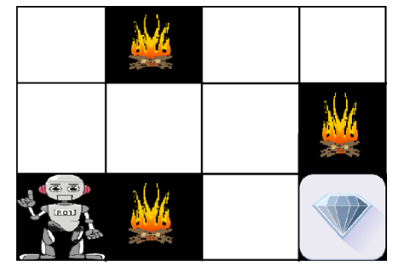

The above image shows the robot, diamond, and fire. The goal of the robot is to get the reward that is the diamond and avoid the hurdles that are fired. The robot learns by trying all the possible paths and then choosing the path which gives him the reward with the least hurdles. Each right step will give the robot a reward and each wrong step will subtract the reward of the robot. The total reward will be calculated when it reaches the final reward that is the diamond.

Difference between Reinforcement learning and Supervised learning:
Reinforcement learning | Supervised learning
Reinforcement learning is all about making decisions sequentially. In simple words, we can say that the output depends on the state of the current input and the next input depends on the output of the previous input. | In Supervised learning, the decision is made on the initial input or the input given at the start.
In Reinforcement learning decision is dependent, So we give labels to sequences of dependent decisions. | In supervised learning the decisions are independent of each other so labels are given to each decision.
Example: Chess game,text summarization. | Example: Object recognition,spam detetction.

--------------------------------------------
Types of Data:
Data can come in many forms, but machine learning models rely on four primary data types. These include numerical data, categorical data, time series data, and text data.
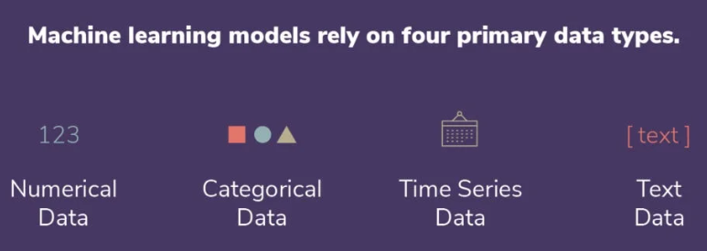

Data types are a way of classification that specifies which type of value a variable can store and what type of mathematical operations, relational, or logical operations can be applied to the variable without causing an error. In machine learning, it is very important to know appropriate datatypes of independent and dependent variable.
The Data Type Is Broadly Classified Into
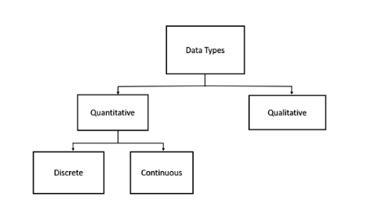
- Quantitative
- Qualitative

Quantitative Data Type:
This Type Of Data Type Consists Of Numerical Values. Anything Which Is Measured By Numbers.

Ex: Profit, Quantity Sold, Height, Weight, Temperature, Etc.

This Is Again Of Two Types

A.) Discrete Data Type:-

The Numeric Data Which Have Discrete Values Or Whole Numbers. This Type Of Variable Value If Expressed In Decimal Format Will Have No Proper Meaning. Their Values Can Be Counted.

Ex.: – No. Of Cars You Have, No. Of Marbles In Containers, Students In A Class, Etc.


Fig: Discrete Data Types

B.) Continuous Data Type: –

The Numerical Measures Which Can Take The Value Within A Certain Range. This Type Of Variable Value If Expressed In Decimal Format Has True Meaning. Their Values Can Not Be Counted But Measured. The Value Can Be Infinite

Ex: – Height, Weight, Time, Area, Distance, Measurement Of Rainfall, Etc.

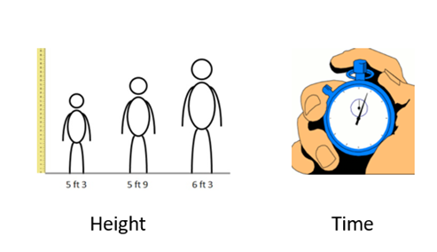
Fig: Continuous Data Types

2. Qualitative Data Type:
These Are The Data Types That Cannot Be Expressed In Numbers. This Describes Categories Or Groups And Is Hence Known As The Categorical Data Type.
This Can Be Divided Into:

A.Structured Data:

This Type Of Data Is Either Number Or Words. This Can Take Numerical Values But Mathematical Operations Cannot Be Performed On It. This Type Of Data Is Expressed In Tabular Format.

Ex:
Sunny=1, Cloudy=2, Windy=3 Or Binary Form Data Like 0 Or1, Good Or Bad, Etc.
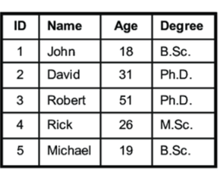
Fig: Structured Data

B. Unstructured Data:

This Type Of Data Does Not Have The Proper Format And Therefore Known As Unstructured Data.
This Comprises Textual Data, Sounds, Images, Videos, Etc.

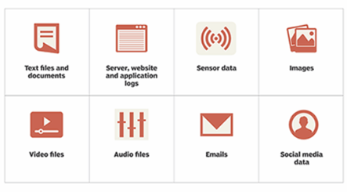
Fig: Unstructured Data
Besides This, There Are Also Other Types Refer As Data Types Preliminaries Or Data Measures:
- Nominal
- Ordinal
- Interval
- Ratio

I. Nominal Data Type:

This Is In Use To Express Names Or Labels Which Are Not Order Or Measurable.

Ex: Male Or Female (Gender), Race, Country, Etc.


Fig: Gender (Female, Male), An Example Of Nominal Data Type

II. Ordinal Data Type:

This Is Also A Categorical Data Type Like Nominal Data But Has Some Natural Ordering Associated With It.

Ex:Likert Rating Scale, Shirt Sizes, Ranks, Grades, Etc.

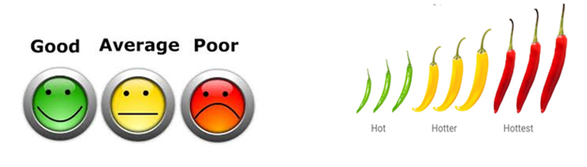
Fig: Rating (Good, Average, Poor), An Example Of Ordinal Data Type

III. Interval Data Type:

This Is Numeric Data Which Has Proper Order And The Exact Zero Means The True Absence Of A Value Attached. Here Zero Means Not A Complete Absence But Has Some Value. This Is The Local Scale.

Ex: Temperature Measured In Degree Celsius, Time, Sat Score, Credit Score, PH, Etc. Difference Between Values Is Familiar. In This Case, There Is No Absolute Zero. Absolute
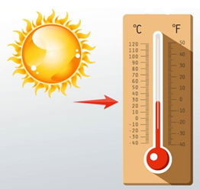
Fig: Temperature, An Example Of Interval Data Type

IV. Ratio Data Type:

This Quantitative Data Type Is The Same As The Interval Data Type But Has The Absolute Zero. Here Zero Means Complete Absence And The Scale Starts From Zero. This Is The Global Scale.
E.G., Temperature In Kelvin, Height, Weight, Etc.


Fig: Weight, An Example Of Ratio Data Type
C. Semi Structured Data:
Semi-structured data is a type of data that does not fit neatly into traditional relational databases (structured data) but still contains organizational properties through metadata or tags. It combines characteristics of both structured and unstructured data.

Characteristics:
- Lacks a Fixed Schema: Unlike structured data, semi-structured data does not adhere to a strict table-based schema.
- Self-Describing: Includes metadata to describe the data structure (e.g., tags, keys).
- Flexible Structure: Can accommodate varying levels of detail and formats, making it more adaptable than structured data.
- Easily Scalable: Handles diverse data sources, which is useful in big data applications.

Ex:
- JSON (JavaScript Object Notation):
{
"name": "Alice",
"age": 25,
"hobbies": ["reading", "hiking"]
}
- XML (eXtensible Markup Language):
<person>
<name>Alice</name>
<age>25</age>
<hobbies>
<hobby>reading</hobby>
<hobby>hiking</hobby>
</hobbies>
</person>
- NoSQL Databases:
  - MongoDB stores semi-structured data as collections of documents in BSON format.
- Emails:
  - Contains structured data (headers like subject, sender) and unstructured data (email body).
- Sensor Data:
  - Data logs from IoT devices often include timestamps and specific attributes but lack a fixed schema.

Use Cases:
- Web Applications:
  - APIs often exchange data in JSON or XML formats for interoperability.
- Big Data Systems:
  - Handles diverse formats in data lakes (e.g., Hadoop).
- Search and Indexing:
  - Logs and metadata from various sources are stored and queried for insights.
- IoT:
  - Semi-structured sensor data is used to monitor and analyze real-time metrics.

Advantages:
- Flexibility: Accommodates diverse and evolving data formats.
- Ease of Use: Metadata enables partial structure, simplifying parsing and querying.
- Scalability: Adapts well to large-scale, heterogeneous datasets.

Challenges:
- Complexity in Querying: Requires specialized tools or frameworks (e.g., NoSQL databases).
- Performance: Processing may be slower than structured data due to lack of indexing.
- Inconsistent Structure: Variability can complicate data integration.
Categorical Data:
Categorical data is sorted by defining characteristics. This can include gender, social class, ethnicity, hometown, the industry you work in, or a variety of other labels.
Categorical data is great for grouping individuals or ideas that share similar attributes, helping your machine learning model streamline its data analysis.

Time series data:
Time series data consists of data points that are indexed at specific points in time. More often than not, this data is collected at consistent intervals. Learning and utilizing time series data makes it easy to compare data from week to week, month to month, year to year, or according to any other time-based metric you desire.
The distinct difference between time series data and numerical data is that time series data has established starting and ending points, while numerical data is simply a collection of numbers that aren’t rooted in particular time periods.

Text data:
Text data is simply words, sentences, or paragraphs that can provide some level of insight to your machine learning models. Since these words can be difficult for models to interpret on their own, they are most often grouped together or analyzed using various methods such as word frequency, text classification, or sentiment analysis.
--------------------------------------------
Matching in Machine learning:
Matching in machine learning refers to the process of finding pairs or groups of items, instances, or entities that are related or similar based on certain criteria. It is used in various applications, such as recommendation systems, causal inference, and natural language processing. The type of matching depends on the problem being solved and the data involved. Here are some common types of matching in machine learning:

1. Entity Matching
Entity matching (also known as record linkage, entity resolution, or deduplication) is the process of identifying and linking records in different datasets that refer to the same real-world entity. This is crucial when combining data from multiple sources or cleaning data to ensure consistency and accuracy. The main purpose is to Identifying records in datasets that refer to the same entity.
- Applications:
  - Deduplication of records in databases.
  - Matching customer profiles across platforms.
- Techniques:
  - Rule-based methods (e.g., exact or fuzzy string matching).
  - Supervised learning models (e.g., using embeddings or similarity scores).
  - Deep learning models (e.g., Siamese networks for text or images).

Ex: Customer Databases
Suppose you have two datasets:

Dataset 1: Online Store Customers
CustomerID | Name | Email | Address
1 | John Smith | john.smith@gmail.com | 123 Elm St, NY
2 | Jane Doe | jane.doe@example.com | 456 Oak St, SF
3 | Mike Johnson | mike.j@company.com | 789 Pine St, TX

Dataset 2: Newsletter Subscribers
SubscriberID | FullName | EmailAddress | City
A | John A. Smith | john.smith@gmail.com | New York
B | Jane Doe | jane.doe@example.com | San Francisco
C | Michael Johnson | mike.j@company.com | Houston
The task is to identify and link records referring to the same individuals across the two datasets.

Challenges in Entity Matching
- Inconsistent Naming: "John Smith" in Dataset 1 is "John A. Smith" in Dataset 2.
- Missing Data: Some fields like "City" or "Address" may be incomplete or not present in both datasets.
- Typographical Errors: Emails like jane.doe@example.com and jane.d@example.com might represent the same person.
- Duplicates: The same entity could appear multiple times in one or both datasets.

2. Feature Matching
Feature matching is a computer vision technique used to find correspondences between key features in images or datasets. It is commonly applied in tasks like image stitching, object recognition, and 3D reconstruction.

Ex: Image Stitching
Suppose you have two overlapping images of a landscape, taken from slightly different angles or positions, and you want to combine them into a single panoramic image. Feature matching can identify corresponding points in both images to align and merge them seamlessly.
The main purpose is Matching features or descriptors in images or other high-dimensional data.
- Applications:
  - Object recognition.
  - Image stitching.
- Techniques:
  - Using descriptors like SIFT, ORB, or SURF.
  - Matching with nearest neighbors or feature similarity metrics.

3. Causal Inference Matching
Causal inference matching is a statistical technique used to estimate the causal effect of a treatment or intervention by comparing treated and untreated units (e.g., individuals, groups, or observations) that are similar in their characteristics.

Ex: Employee Productivity
Suppose you want to evaluate the impact of a training program (treatment) on employee productivity. You have data on employees who participated in the program (treated group) and those who did not (control group).

Dataset Example
EmployeeID | Training (Treatment) | Productivity (Outcome) | Age | Experience | Department
1 | 1 (Yes) | 85 | 30 | 5 | Sales
2 | 0 (No) | 60 | 29 | 5 | Sales
3 | 1 (Yes) | 90 | 40 | 10 | IT
4 | 0 (No) | 88 | 39 | 11 | IT
5 | 1 (Yes) | 70 | 25 | 2 | HR
6 | 0 (No) | 65 | 26 | 3 | HR

Applications:
Evaluating the effect of treatments or interventions in observational studies.
Techniques:
  - Propensity score matching.
  - Nearest-neighbor matching.
  - Optimal matching algorithms.

4. Recommendation Systems Matching
Recommendation systems use matching to pair users with items (products, services, media, etc.) based on their preferences, behavior, or characteristics. Matching is a core component in both collaborative and content-based filtering approaches. It identifies relationships between users and items or between items themselves.
Ex: Movie Recommendation System
Imagine a platform like Netflix that recommends movies to users based on their past viewing history, ratings, or demographic information.

User-Item Interaction Matrix
 | Movie A | Movie B | Movie C | Movie D
User1 | 5 | 3 | 0 | 0
User2 | 4 | 0 | 0 | 5
User3 | 0 | 0 | 5 | 4
User4 | 3 | 4 | 0 | 0

User-user Matching-
- User1 and User4 have similar ratings for Movies A and B.
- Recommend Movie C (rated by User4 but not yet watched by User1).
Item-Item Matching:
- Movie A and Movie B are often liked by similar users.
- Recommend Movie B to a user who liked Movie A.
Applications:
  - E-commerce product recommendations.
  - Movie and music recommendation systems.
Techniques:
  - Collaborative filtering.
  - Content-based filtering.
  - Hybrid recommendation systems.

5. Natural Language Matching
Natural Language Matching involves comparing text (e.g., sentences, phrases, or documents) to identify semantic or syntactic similarity. This is commonly used in tasks like:
- Question answering systems
- Duplicate question detection (e.g., Quora, Stack Overflow)
- Search engines
- Chatbots for intent recognition

Ex: Duplicate Question Detection
Suppose you're building a platform like Quora and want to detect if two questions are duplicates.

Dataset Example
Question 1 | Question 2 | Duplicate
How do I start learning Python? | What is the best way to learn Python? | Yes
What is the capital of France? | How can I travel to France? | No
Tips for improving programming? | How can I become a better programmer? | Yes

Applications:
  - Question-answer retrieval.
  - Document similarity search.
Techniques:
  - Word embeddings (e.g., Word2Vec, GloVe).
  - Sentence embeddings (e.g., BERT, Sentence-BERT).
  - Deep learning models like transformers.

6. Graph Matching
Graph matching refers to identifying correspondences between the nodes, edges, or structures of two or more graphs. It is widely used in applications such as pattern recognition, computer vision, network analysis, and bioinformatics.

Ex: Social Network Analysis
Imagine two social networks where nodes represent individuals and edges represent friendships. Graph matching can help identify similar individuals or groups across these networks.
Graph 1 (G1):
Node | Neighbors
A | B, C
B | A, D
C | A, D
D | B, C
Graph 2 (G2):
Node | Neighbors
W | X, Y
X | W, Z
Y | W, Z
Z | X, Y

Find a mapping between nodes in Graph 1 (G1) and Graph 2 (G2) such that the structure of the graphs is preserved.
Applications:
  - Social network analysis.
  - Molecule comparison in bioinformatics.
Techniques:
  - Graph embedding methods.
  - Spectral matching.
  - Hungarian algorithm for bipartite graph matching.

7. Cross-Domain Matching
Cross-domain matching refers to finding correspondences or relationships between entities, objects, or data points in different domains. These domains can vary in nature, such as text vs. images, different languages, or different types of datasets (e.g., product catalogs from two retailers).

Ex: Matching Products Across E-Commerce Platforms
Suppose two e-commerce platforms, Platform A and Platform B, sell similar products but use different descriptions, names, or categories. Cross-domain matching can identify products that are the same across these platforms to merge catalogs or enable price comparison.

Platform A
Product Name | Price | Category | Description
iPhone 14 | $999 | Smartphones | Latest Apple iPhone model.
Sony WH-1000XM5 | $349 | Headphones | Noise-canceling wireless headset.
MacBook Pro 16-inch | $2499 | Laptops | High-performance Apple laptop.

Platform B
Product Title | Cost | Type | Product Details
Apple iPhone 14 Pro | $999 | Mobile Phones | Newest iPhone with A16 chip.
WH-1000XM5 by Sony | $349 | Audio Devices | Top-rated noise-canceling headphones.
MacBook Pro 16” | $2499 | Computers | Powerful Apple MacBook Pro.

Applications:
  - Multi-modal learning (e.g., matching text and images).
Techniques:
  - Canonical correlation analysis (CCA).
  - Deep learning models with multi-modal architectures.
----------------------------------------------
Stages in Machine Learning/Life cycle of Machine Learning:
Machine learning has given the computer systems the abilities to automatically learn without being explicitly programmed. But how does a machine learning system work? So, it can be described using the life cycle of machine learning. Machine learning life cycle is a cyclic process to build an efficient machine learning project. The main purpose of the life cycle is to find a solution to the problem or project.
Machine learning life cycle involves seven major steps, which are given below:
- Gathering Data
- Data preparation
- Data Wrangling
- Analyse Data
- Train the model
- Test the model
- Deployment
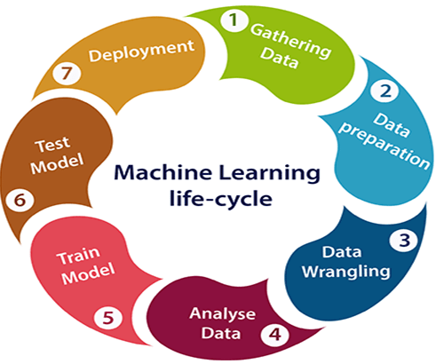

1. Gathering Data:
Data Gathering is the first step of the machine learning life cycle. The goal of this step is to identify and obtain all data-related problems.
In this step, we need to identify the different data sources, as data can be collected from various sources such as files,database,internet, or mobile devices. It is one of the most important steps of the life cycle. The quantity and quality of the collected data will determine the efficiency of the output. The more will be the data, the more accurate will be the prediction.
This step includes the below tasks:
- Identify various data sources
- Collect data
- Integrate the data obtained from different sources
By performing the above task, we get a coherent set of data, also called as a dataset. It will be used in further steps.

2. Data preparation
After collecting the data, we need to prepare it for further steps. Data preparation is a step where we put our data into a suitable place and prepare it to use in our machine learning training.
In this step, first, we put all data together, and then randomize the ordering of data.
This step can be further divided into two processes:
- Data exploration:
It is used to understand the nature of data that we have to work with. We need to understand the characteristics, format, and quality of data.
A better understanding of data leads to an effective outcome. In this, we find Correlations, general trends, and outliers.
- Data pre-processing:
Now the next step is preprocessing of data for its analysis.

3. Data Wrangling
Data wrangling is the process of cleaning and converting raw data into a useable format. It is the process of cleaning the data, selecting the variable to use, and transforming the data in a proper format to make it more suitable for analysis in the next step. It is one of the most important steps of the complete process. Cleaning of data is required to address the quality issues.
It is not necessary that data we have collected is always of our use as some of the data may not be useful. In real-world applications, collected data may have various issues, including:
- Missing Values
- Duplicate data
- Invalid data
- Noise
So, we use various filtering techniques to clean the data.
It is mandatory to detect and remove the above issues because it can negatively affect the quality of the outcome.

4. Data Analysis
Now the cleaned and prepared data is passed on to the analysis step. This step involves:
- Selection of analytical techniques
- Building models
- Review the result
The aim of this step is to build a machine learning model to analyze the data using various analytical techniques and review the outcome. It starts with the determination of the type of the problems, where we select the machine learning techniques such as Classification,Regression,Cluster analysis,Association, etc. then build the model using prepared data, and evaluate the model.
Hence, in this step, we take the data and use machine learning algorithms to build the model.

5. Train Model
Now the next step is to train the model, in this step we train our model to improve its performance for better outcome of the problem.
We use datasets to train the model using various machine learning algorithms. Training a model is required so that it can understand the various patterns, rules, and, features.

6. Test Model
Once our machine learning model has been trained on a given dataset, then we test the model. In this step, we check for the accuracy of our model by providing a test dataset to it.
Testing the model determines the percentage accuracy of the model as per the requirement of project or problem.

7. Deployment
The last step of machine learning life cycle is deployment, where we deploy the model in the real-world system.
If the above-prepared model is producing an accurate result as per our requirement with acceptable speed, then we deploy the model in the real system. But before deploying the project, we will check whether it is improving its performance using available data or not. The deployment phase is similar to making the final report for a project.
----------------------------------------
Data Acquisition:
Data acquisition in machine learning is the process of gathering and converting data from the real world into digital values so that it can be analyzed and stired in a computer.
Ex:
- Measuring the temperature of a room using a thermocouple
- Collecting data from an organization's databases, such as customer transactions, website traffic, or sensor readings
- Collecting user data from Amazon, such as browsing history, purchase history, and ratings
Components of data acquisition
- Sensor
Also known as a transducer, a sensor converts physical phenomena into electrical signals
- Signal conditioner
Checks the analog signals from the sensor and adjusts, isolates, filters, or increases them
- Analog-to-digital converter (ADC)
A microprocessor that converts the analog signal into data that a computer can process
Data acquisition systems
- Computer-connected DAQ modules:These modules are connected to a computer
- Stand-alone data acquisition systems:These systems have a built-in computer
- Rack-mounting data acquisition systems:These systems are mounted on racks
- Wireless data acquisition systems:These systems use wireless communication technologies like Wi-Fi, Bluetooth, or Zigbee to transmit data.

Key Steps in Data Acquisition
- Identify the Data Source:
  - Data can come from structured (databases, APIs) or unstructured (text, images, videos) sources.
  - Examples: IoT sensors, social media, public datasets, or web scraping.
- Data Collection:
  - Gather the data using appropriate methods like database queries, scraping scripts, or API requests.
  - Ensure you comply with legal and ethical standards (e.g., GDPR, copyright laws).
- Data Cleaning:
  - Remove duplicates, fill in missing values, and filter out irrelevant data.
  - Address issues like inconsistent formatting or noisy data.
- Data Transformation:
  - Convert raw data into a format suitable for modeling (e.g., normalization, one-hot encoding, feature engineering).
- Data Storage:
  - Store the data securely in a database or cloud service for easy access.

Ex:

Predicting House Prices
You want to train a machine learning model to predict house prices based on features like square footage, number of bedrooms, and location.
- Data Source:
  - Use a public dataset (e.g., Zillow, Kaggle dataset) or scrape real estate websites.
- Collection:
  - Collect data via a web scraping script (e.g., using Python's BeautifulSoup) or download the dataset from a repository.
- Cleaning:
  - Handle missing values: Replace missing prices with the median price.
  - Remove outliers: Eliminate houses with unrealistically high/low prices.
- Transformation:
  - Normalize numerical features (e.g., scale square footage to [0, 1]).
  - One-hot encode categorical features like "location" (convert city names into binary vectors).
- Storage:
  - Save the cleaned and transformed data in a CSV file or a database for model training.
---------------------------------
Feature Engineering:
Feature engineering is the process of selecting, transforming, and creating new features from raw data to improve the performance of machine learning models. It is one of the most critical steps in the ML pipeline, as the quality and relevance of features directly impact the model's accuracy and effectiveness.

Key Steps in Feature Engineering
- Understand the Data:
  - Analyze the dataset to identify the relationships between features and the target variable.
- Feature Selection:
  - Choose the most relevant features by eliminating irrelevant, redundant, or noisy ones.
  - Techniques: Correlation analysis, Recursive Feature Elimination (RFE), or using domain knowledge.
- Feature Transformation:
  - Modify existing features to make them more useful for the model.
  - Examples: Scaling, normalization, log transformation, or encoding categorical variables.
- Feature Creation:
  - Derive new features by combining, splitting, or aggregating existing ones.
  - Examples: Creating interaction terms, extracting date components, or calculating ratios.
- Feature Encoding:
  - Convert categorical features into numerical representations for machine learning models.
  - Examples: One-hot encoding, label encoding, or ordinal encoding.
- Feature Scaling:
  - Standardize or normalize numerical features to ensure all have comparable scales.

Example: Predicting Customer Churn
You want to predict whether a customer will churn (leave the service) based on their activity data.

Raw Dataset:
Customer_ID | Age | Tenure (months) | Monthly_Charges | Contract_Type | Churn
1 | 45 | 12 | 60 | Month-to-Month | Yes
2 | 34 | 24 | 80 | One Year | No

Feature Engineering Steps:
- Feature Selection:
  - Analyze which features impact churn most. Retain "Tenure," "Monthly_Charges," and "Contract_Type."
- Feature Transformation:
  - Log-transform "Monthly_Charges" to reduce skewness if it has extreme values.
- Feature Creation:
  - Create a new feature, "Avg_Charge_Per_Tenure" = Monthly_Charges / Tenure.
- Feature Encoding:
  - One-hot encode "Contract_Type" into binary columns.
- Feature Scaling:
  - Normalize numerical features like "Tenure" and "Monthly_Charges."
-----------------------------
Data Representation in Machine Learning:
Data representation refers to the way raw data is structured and encoded so that it can be effectively used by machine learning (ML) algorithms. Proper representation ensures that the features of the data capture meaningful information about the problem, allowing the model to learn effectively.

Types of Data Representations
- Numerical Data:
  - Represented as continuous or discrete numbers.
  - Examples: Age, income, temperature.
- Categorical Data:
  - Represented as categories or labels.
  - Encoding methods: One-hot encoding, label encoding.
  - Examples: Gender (Male, Female), Colors (Red, Green, Blue).
- Text Data:
  - Represented using embeddings or numerical features.
  - Methods: Bag of Words (BoW), TF-IDF, Word2Vec, BERT.
  - Example: Sentiment analysis of customer reviews.
- Image Data:
  - Represented as pixel values, typically in 2D arrays for grayscale or 3D arrays for color images (RGB).
  - Example: Handwritten digit recognition using MNIST dataset.
- Time Series Data:
  - Represented as sequences of data points indexed by time.
  - Example: Stock prices over a month.
- Graph Data:
  - Represented using nodes and edges to capture relationships.
  - Example: Social network analysis.

Example: Predicting Customer Churn (Data Representation)
Customer_ID | Age | Tenure (months) | Monthly_Charges | Contract_Type | Churn
1 | 45 | 12 | 60 | Month-to-Month | Yes
2 | 34 | 24 | 80 | One Year | No

Step-by-Step Representation:
- Numerical Features:
  - Use "Age," "Tenure," and "Monthly_Charges" as-is or scale them to a uniform range (e.g., [0, 1]).
- Categorical Features:
  - Convert "Contract_Type" into numerical form using One-Hot Encoding:
    - Month-to-Month → [1, 0, 0]
    - One Year → [0, 1, 0]
- Target Variable:
  - Convert "Churn" into binary labels:
    - Yes → 1
    - No → 0
--------------------------------------------------

Model Selection in Machine Learning
Model selection involves choosing the most suitable machine learning algorithm for a given problem, dataset, and desired performance metric. It is a critical step in the ML pipeline, as the choice of model impacts accuracy, training time, and interpretability.

Steps in Model Selection
- Define the Problem:
  - Is it regression, classification, clustering, or another type of ML task?
- Understand the Dataset:
  - Analyze the dataset size, feature types, and target variable.
- Choose Candidate Models:
  - Based on the problem type and data characteristics, shortlist models.
  - Examples:
    - Regression: Linear Regression, Decision Tree Regressor, Random Forest.
    - Classification: Logistic Regression, SVM, K-Nearest Neighbors (KNN), Neural Networks.
    - Clustering: K-Means, DBSCAN, Hierarchical Clustering.
- Evaluate Models:
  - Use techniques like cross-validation to assess model performance on the dataset.
  - Choose metrics relevant to the problem, such as accuracy, precision, recall, F1-score, or RMSE.
- Hyperparameter Tuning:
  - Optimize the selected model's hyperparameters using grid search, random search, or automated methods (e.g., Bayesian optimization).
- Compare and Select:
  - Compare models based on performance metrics, computational efficiency, and interpretability, then select the best one.

Example: Predicting House Prices (Regression Problem)

Dataset:
- Target Variable: House prices.
- Features: Square footage, number of bedrooms, location, etc.

Steps:
- Define the Problem:
  - Task: Predicting a continuous variable (regression problem).
- Understand the Dataset:
  - Moderate dataset size with numerical and categorical features.
- Choose Candidate Models:
  - Linear Regression.
  - Random Forest Regressor.
  - Gradient Boosting Regressor.
- Evaluate Models:
  - Use cross-validation to calculate the Root Mean Squared Error (RMSE) for each model.

Model selection Process:
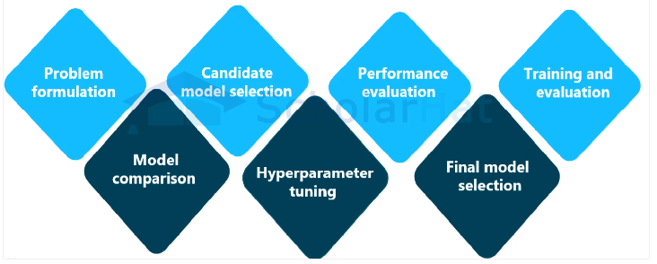

Problem formulation:Clearly express the issue at hand, including the kind of predictions or task that you'd like the model to carry out (for example, classification, regression, or clustering).
- Candidate model selection: Pick a group of models that are appropriate for the issue at hand. These models can include straightforward methods like decision trees or linear regression as well as more sophisticated ones like deep neural networks, random forests, or support vector machines.
- Performance evaluation:Establish measures for measuring how well each model performs. Common measurements include area under the receiver's operating characteristic curve (AUC-ROC), recall, F1-score, mean squared error, and accuracy, precision, and recall. The type of problem and the particular requirements will determine which metrics are used.
- Training and evaluation:Each candidate model should be trained using a subset of the available data (the training set), and its performance should be assessed using a different subset (the validation set or via cross-validation). The established evaluation measures are used to gauge the model's effectiveness.
- Model comparison:Evaluate the performance of various models and determine which one performs best on the validation set. Take into account elements like data handling capabilities, interpretability, computational difficulty, and accuracy.
- Hyperparameter tuning:Before training, many models require that certain hyperparameters, such as the learning rate, regularisation strength, or the number of layers that are hidden in a neural network, be configured. Use methods like grid search, random search, and Bayesian optimization to identify these hyperparameters' ideal values.
- Final model selection:After the models have been analyzed and fine-tuned, pick the model that performs the best. Then, this model can be used to make predictions based on fresh, unforeseen data.
-------------------------------------------

Model Learning:

